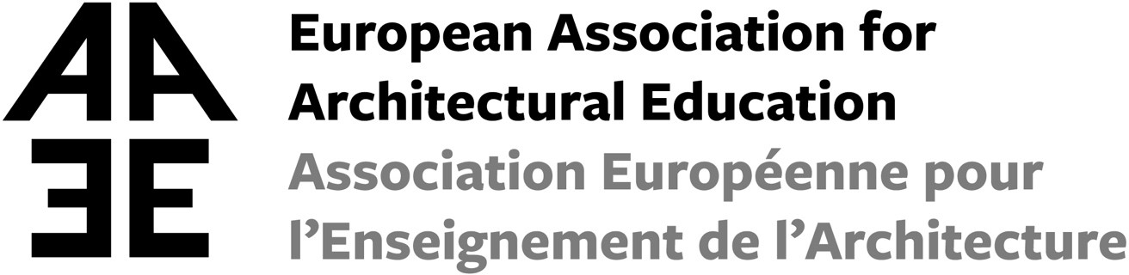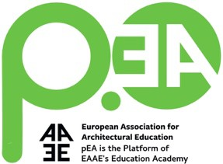

EAAE Education Academy invites you to the
Remote Teaching Workshops

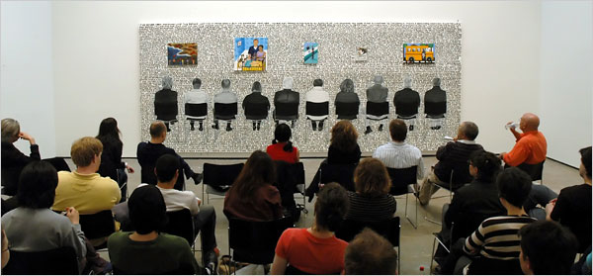

The EAAE Education Academy concludes its new series of three workshops focused on architectural design remote teaching issues.

WS 1. 05.02.20 Remote entry: First year experience
(Moderator Michela Barosio)
WS 2. 05.03.20 Working alone, together: Organizing Group work
(Moderator Mia Roth-Čerina)
WS 3. 02.04.20 Judging from a distance: Final Jury and assessment
(Moderator Patrick Flynn)
WS 3. Judging from a distance
The review and feedback process for students aims to foster a culture of learning and reflective practice. In real life settings this is frequently delivered through the ‘crit’, short for ‘criticism’, where the students’ work is used as a learning tool for all the class through a judging of the work in an open public setting. In this scenario the ‘crit’ is bound by a specific time and place with associated rituals and roles well established and defined.
The online learning space allows for a rethinking of how feedback, judging and reviews can be re-imagined. In the new setting can the new feedback process change of locus of control from tutor centred to increasing student engagement and self-critical reflection? Does this new online world allow a wider range of voices from different disciplines and international backgrounds inform the teaching process? Can the new method of delivering feedback and critique lead to the design of new inclusive, collaborative assessment and feedback processes or does it hinder this aim? Is it possible to use this method to increase student engagement and their development of critical reflection skills across an architecture programme? What has been gained and what has been lost through the move to online judging? Will this type of delivery of feedback remain in the long term or will feedback and critique return to its former shape?

Call for presentations and papers
These are some of the themes that the upcoming Workshop 3 aims to address. We are looking for examples of good practice from within architectural education, in which the author takes a position. The workshop will be framed around your own experiences of how you have managed judging from a distance.

Invitation for participation
Unlike many other academic conferences and seminars, the EAAE EA workshops do not consist of paper presentations only. The workshops operate through working sessions based upon intensive debate among all participants in smaller groups. Therefore, we need more voices and thoughts than paper presentations. The Education Academy aims to be a platform and think-tank where concerns and best-practices all across Europe can be shared. We thus invite each architectural educator within the community of the EAAE to join the workshop and participate in the debate, also without submitting an abstract.

The outcome of the workshop
After the workshop, selected speakers will be asked to formalize their presentation in a paper of maximum of 4 pages including images, taking into consideration the workshop debate. The collected contributions will be published online through p.EA – the Platform of the Education Academy, and the collected papers as an e-book of the EAAE.

Organizing and scientific team
Johan De Walsche (EA main coordinator – University of Antwerp)
Michela Barosio (Politecnico di Torino)
Patrick Flynn (TU Dublin)
Mia Roth-Čerina (University of Zagreb)

Remote Teaching Workshop 3, 14:00 CET April 2nd, 2021,

https://us02web.zoom.us/j/8054483508

Schedule

2.00 pm Welcome and introduction to the workshop
Johan De Walsche EA main coordinator – University of Antwerp
Patrick Flynn – TU Dublin

2.15 pm Session 1: Reflection & Planning for the Future

Observations and provocations: towards inclusive online design feedback and assessment practices
Hermie Delport & Jolanda Morkel : STADIO Higher Education Institution
Michele Gorman & Lindy Burton : The New School Queensland University of Technology

Rethinking The Crit: CoCreation of Knowledge
Johanna Cleary & Sarah Sheridan
TU Dublin
Overturned Spaces of Learning
Daniele Campobenedetto & Tommaso Listo
(with support of Caterina Barioglio, Valeria Federighi, Edoardo Bruno and Dalila Tondo)
Politecnico di Torino

3.00 pm Discussion

3.25 pm Break

3.45 pm Session 2: Innovation & Considering the Past

Student-centric aspects of the Online Exhibition platform
David Shanks & Chee Kit Lai
Bartlett School of Architecture
Constructing The Drawing Table as a Polyphonic Ritualistic Site: Shifting Remoteness into Poetic Distance
Bahar Avanoğlu
Istanbul Bilgi University

Zoom Room with a View: The Proximity and Distance of the Online Revie
Alice Clancy and Laura Harty
AC – University College Dublin, LH – University of Edinburgh

4.30 pm Discussion

4.55 pm Closing Comments

