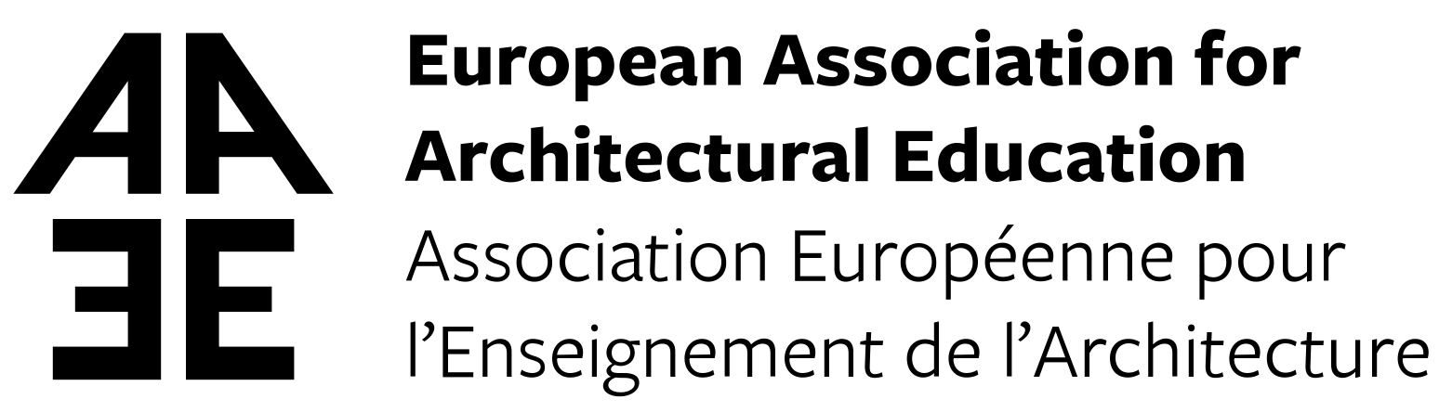
Research Academy
Invitation
for Participation in the Meeting
Research Impact and Doctoral Training

Antwerp, 26 June 2019, 16.00-19.00 and 27 June 2019, 10.00-13.00
University of Antwerp, Campus Mutsaard, Blindestraat 4-22, Antwerp

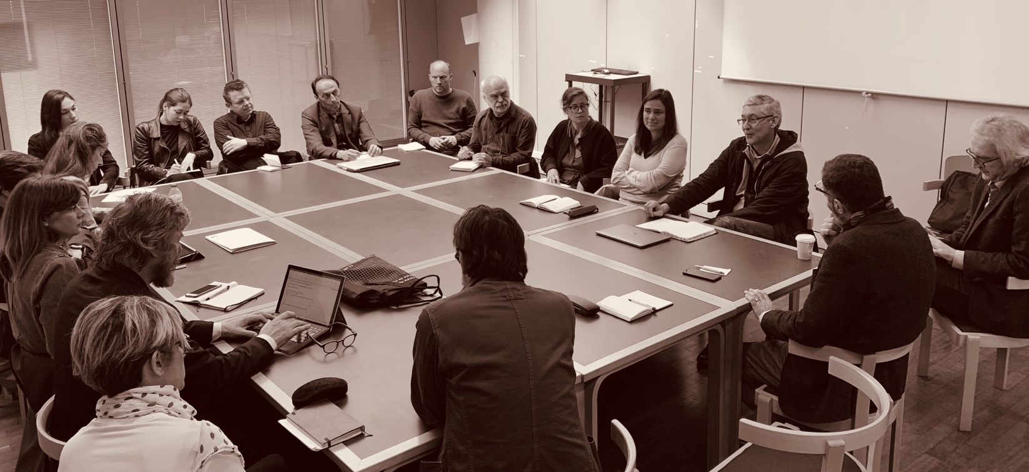The EAAE Research Academy (RA) is a think-tank, articulating and promoting common concerns and interest in architectural research. It offers a platform for reflecting upon, and responding to topical issues, thus revealing and underpinning actions, claims, and positions to be taken, inside and outside of EAAE.

Discussion:
Experiences with Policy Papers

In continuation with the Zagreb and Lisbon discussions, this meeting should develop on the three working-groups’ topics:

1. IMPACT EVIDENCE OF NON-WRITTEN PRODUCTION
2. ARCHITECTURE AS A RECOGNIZED RESEARCH DISCIPLINE
3. CRITICAL MASSES OF ARCHITECTURAL RESEARCH

Download the EAAE RA working documents here.
Upload your materials for each working group here or send them to Débora Domingo-Calabuig.

We cordially invite you to develop the EAAE Research Academy mission!

Meeting contact: tadeja.zupancic@fa.uni-lj.si
Organizers: Tadeja Zupančič, Debora Domingo Calabuig
The RA info updates: http://www.eaae.be/eaae-academies/research-academy/

